M.Sc Entrance Coaching Classes for Higher Education
Department of Chemistry
SVCR Govt. Degree College, Palamaner
…………………………………………………………………………….

- M.Sc Chemistry Coaching classes were started from 06-01-2021. Nearly 4 months the classes were continued.
- Inauguration of Coaching for M.Sc CHEMISTRY Entrance Classes: Inaugurated by the College Principle Dr. Babu Garu
- Lecturers participated in this programme were
P Bhanu Prakash
Dr G Chinna reddy
Talari Balaji

Head of the Department
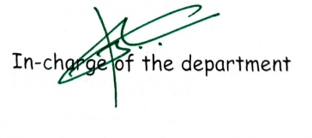

Signature of the Lecturer
1.
2.

- 19 Students Enrolled for this Coaching and 9 students were selected for various universities in Andhra Pradesh
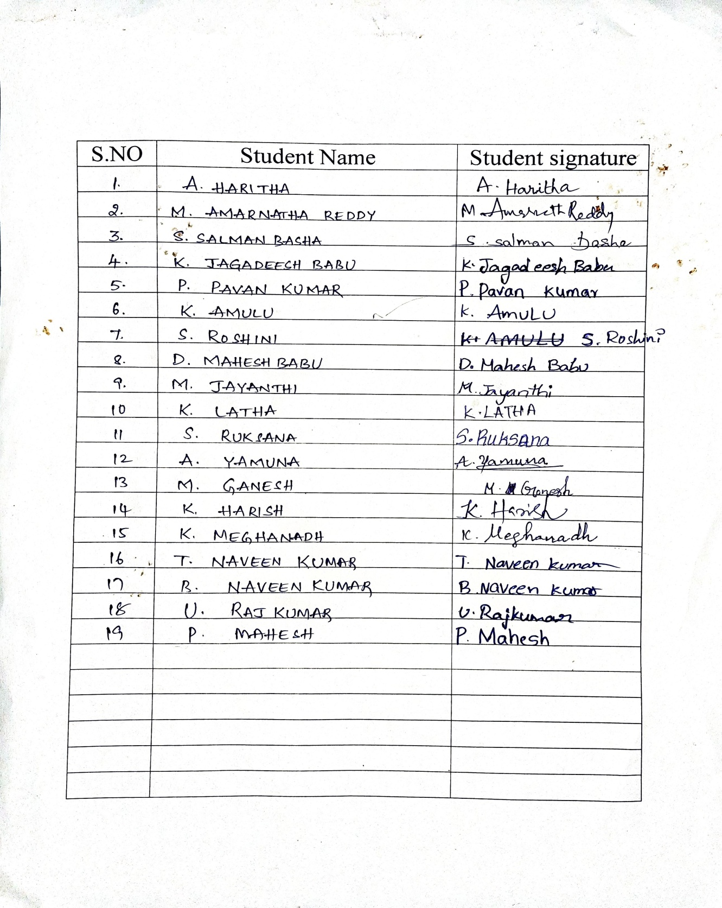

The list of students got admission for M.Sc Chemistry
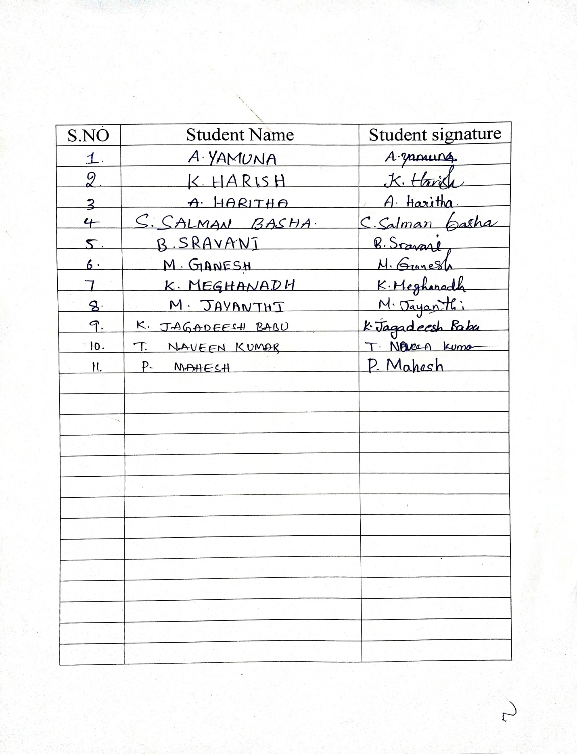

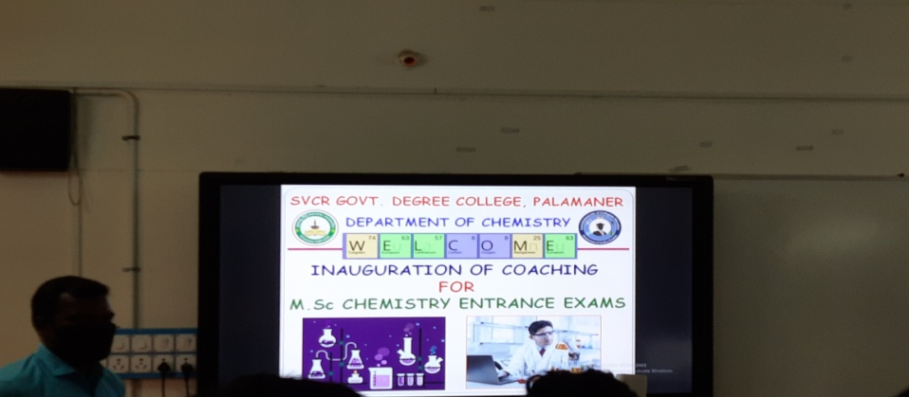
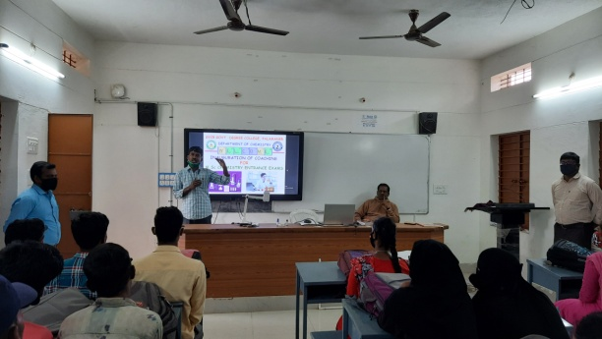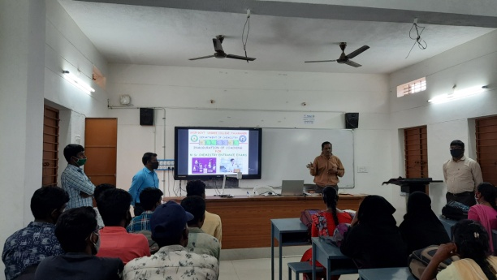
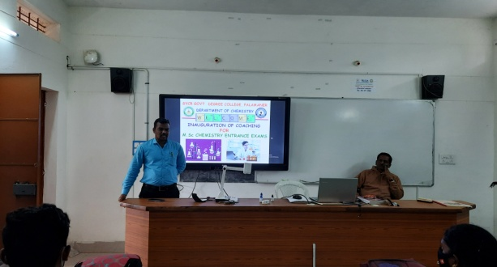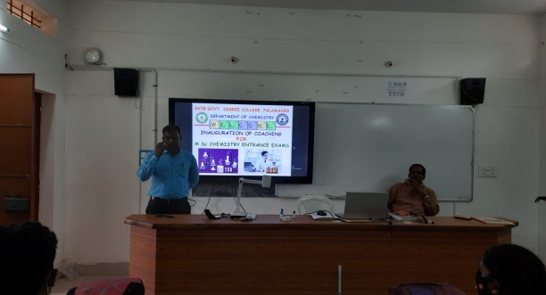
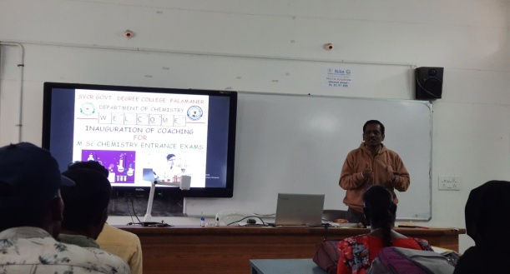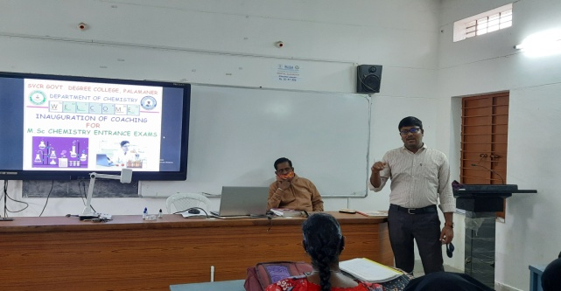

The list of students and the University names where they got admission for M.Sc Chemistry.

1. Syed Salman Basha- Vikrama Simhapuri University
2. K Meghanadh- Yogivemana University
3. Kothannagari Harish- Yogivemana University
4. K Jagadeesh Babu- PVKN GDC Chittoor
5. M Ganesh- SV University
6. M Jayanthi- Sri Padmavathi Mahila Viswavidyalayam
7. P Mahesh Yogivemana University
8. Thoti Naveen Kumar- Yogivemana University
9. A Haritha- Yogivemana University

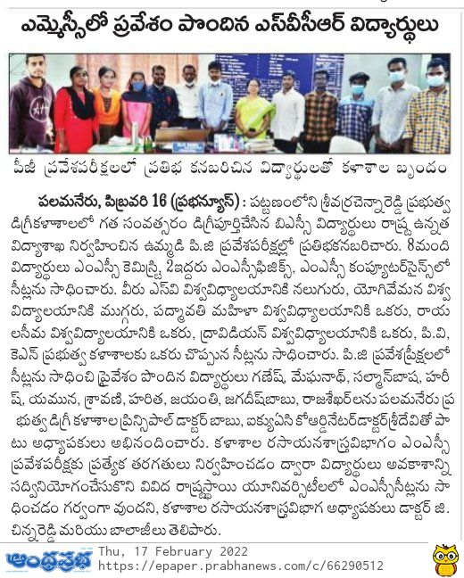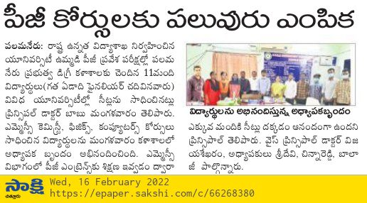

Feedback of the Students about College and Department of Chemistry
